ENGG1340 Computer Programming II

**Module 2 Checkpoint Exercise**

Name: Adrio Alimin

University ID: 3035603978

**Instructions:**

For each single question or each group of questions in the Checkpoint exercise, please type your answer right after the question in this Word document. Please refer to the example below.

Checkpoint 0:

What is the meaning of the command “date”?

Ans: The “date” command prints the current date of the current machine

**Checkpoint 2.1 (Please submit your answer to Moodle)**

What is the output of the following shell script? Please explain your answer.

|  |
| --- |
| #!/bin/bash  a=100  b=99  if [ $a \> $b ]  then  echo "$a is larger"  else  echo "$b is larger"  fi  if [ $a -gt $b ]  then  echo "$a is larger"  else  echo "$b is larger"  fi |

Note: If you are using your own Linux, you may need to grant execute permission to run it.

**99 is larger**

**100 is larger**

**The first if-then-else block does string sorting comparison (“100” is not sorted after “99” i.e. “99 is sorted before “100”)**

**The second if-then-else block does *number* comparison (100 is sorted before 99).**

**Checkpoint 2.2: Shell Script to mark all assignments (Please evaluate your answer on Moodle)**

Let’s upload the module files to the Linux server and browse to ~/Module2/Assignments/

|  |
| --- |
| $ cd ~/Module2/Assignments/  $ ls  2012111111 2012222222 2012333333 input.txt correct.txt mark.sh |

Let’s write a script to mark all the assignments in a class!

1. Suppose that the submission of each student is organized in the directory Assignments/UID, where UID is the University number of the student.
2. In this example we have three students with UID 2012111111, 2012222222 and 2012333333.
3. The test cases input.txt and correct.txt are located in the Assignments directory.
4. The shell script mark.sh is under the Assignments directory, to be updated by you.

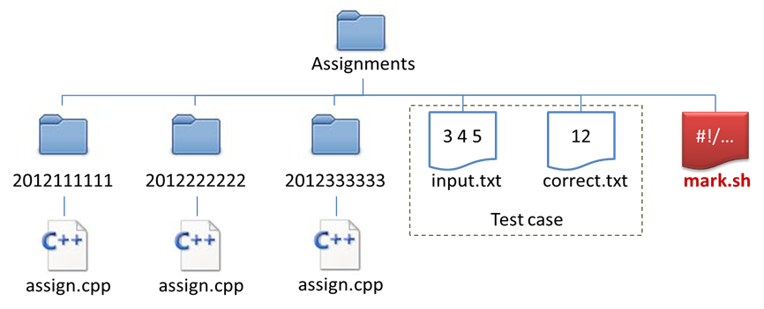

Consider the unfinished shell script *mark.sh*

|  |
| --- |
| #!/bin/bash  allStudents=**Q1**  for student in $allStudents  do  if **Q2**  then  cd $student  if **Q3**  then  g++ assign.cpp -o assign.o 2>error.txt  if **Q4**  then  ./assign.o < ../input.txt > output.txt  result=`diff output.txt ../correct.txt`  if **Q5**  then  echo "$student: Wrong answer."  else  echo "$student: Correct!"  fi  else  echo "$student: Cannot be compiled."  fi  fi  cd ..  fi  done |

Question1:

* What should be the code in Q1? (Reminder, spacing is critical!)
* Hints : First we need to get the names of the files and directories under our current directory, what is the command to do this? How we can execute shell command in shell script and store the result in the variable allStudents?

**“`ls ~/Module2/Assignments/`”**

Question 2:

* However, the command in Q1 also returns files under the Assignments directory, such as the test case files *input.txt* and *correct.txt*, as well as the shell script *mark.sh*.
* We need an if statement, what should be the condition in Q2?
* Hints: How can we check if $student is a directory?

**[ -d $student ]**

Question 3:

* After we have identified the student’s directories and browse into them one by one using the cd $student command, we need to check if the student has submitted *assign.cpp* or not.
* What is the condition to be filled in Q3?

**[ -e “assign.cpp” ]**

Question 4:

* If the student has submitted *assign.cpp*, we then need to compile the *assign.cpp*, and report on screen if it cannot be compiled.
* We need to check if *assign.cpp* can be compiled or not.
* What is the condition to be filled in Q4?
* Hints: if the compilation is successful, what file will be created after executing the line

g++ assign.cpp -o assign.o 2> error.txt ?

**[ -e “assign.o” ]**

Question 5:

* If the student has submitted *assign.cpp*, and *assign.cpp* can be compiled, we then need to check if the output file *output.txt* is the same as the test case correct.txt or not.
* The result=`diff output.txt ../correct.txt` command will store some value in the variable $result if *output.txt* is different from *correct.txt*.
* Therefore, if the length of the string $result is NOT EQUAL to 0, then there is something output by the diff command, that means *assign.o* returns wrong answer.
* What is the condition to be filled in Q5?

**[ ${#result} != 0 ]**

Upload your answer to the Moodle page “**Shell Script to mark all assignments**” under Module 2 and evaluate it.

**Checkpoint 2.3**

GitHub has an education plan to allow university students to apply for a professional account for free for at least two years. All students can join at <https://education.github.com/>.

Later for student projects, we plan to request students to commit their code and changes to GitHub mandatorily.

To apply for the professional account, you must:

1. Prepare a digital copy of your Student ID card.
2. Create a free GitHub account at <https://github.com/>.
3. Join the “GitHub Education” at <https://education.github.com/>.

Here are some steps to join the GitHub Education:

1. Specify you are a **student** and creating an **individual account**. Then click “Next”.
2. Add your HKU email address and then click “add”. A verification email will be sent to your HKU mailbox. Click the link in the email to verify it. After that, refresh the current page and upload the photo of your student ID card to the space provided. Then click “Submit request” 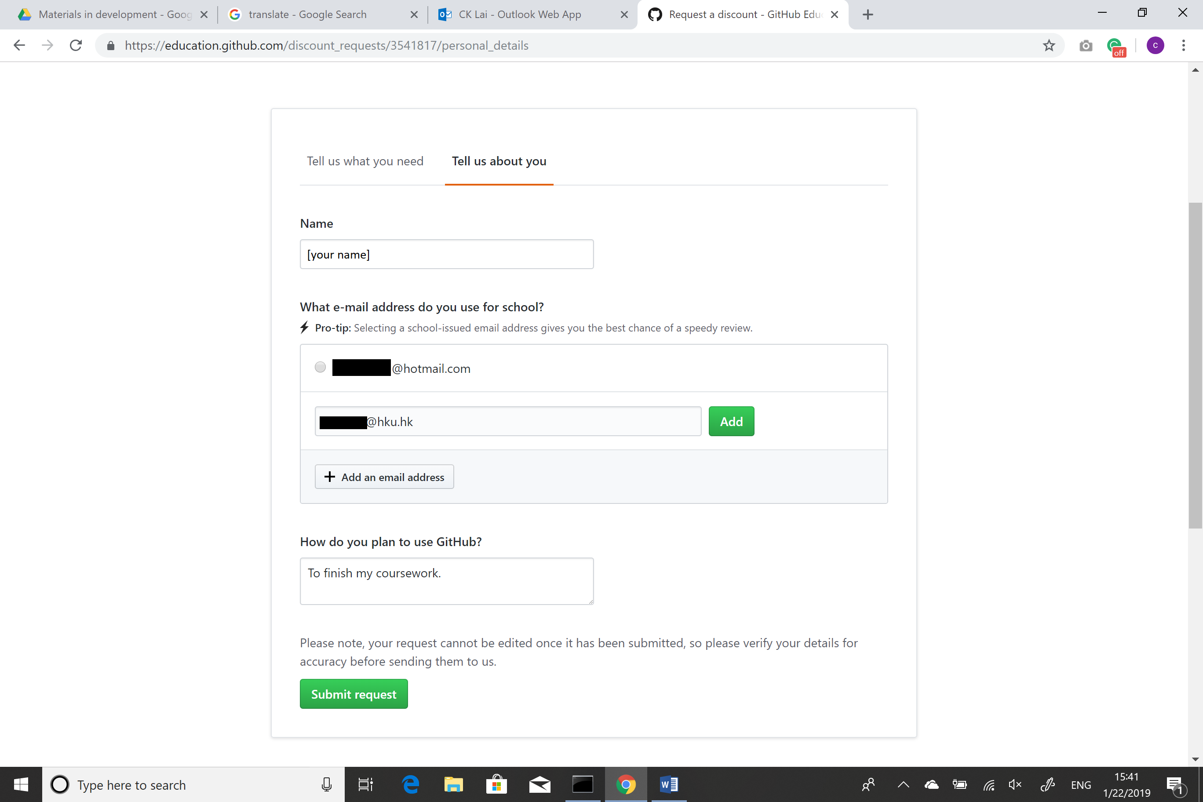
3. You will be notified your application result within 5 days 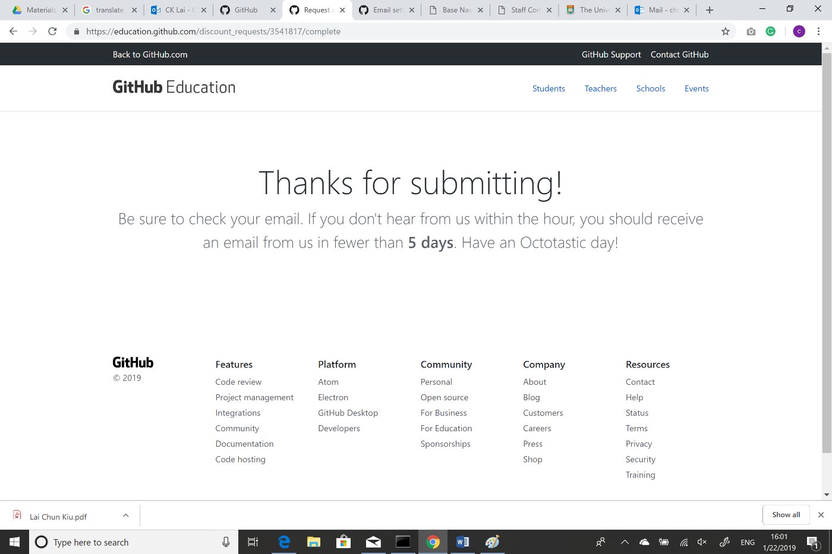

**Checkpoint 2.4: Shell Script to analyze web log (Please evaluate your answer on Moodle)**

Refer to Moodle page “**Shell Script to analyze web log**” for details.